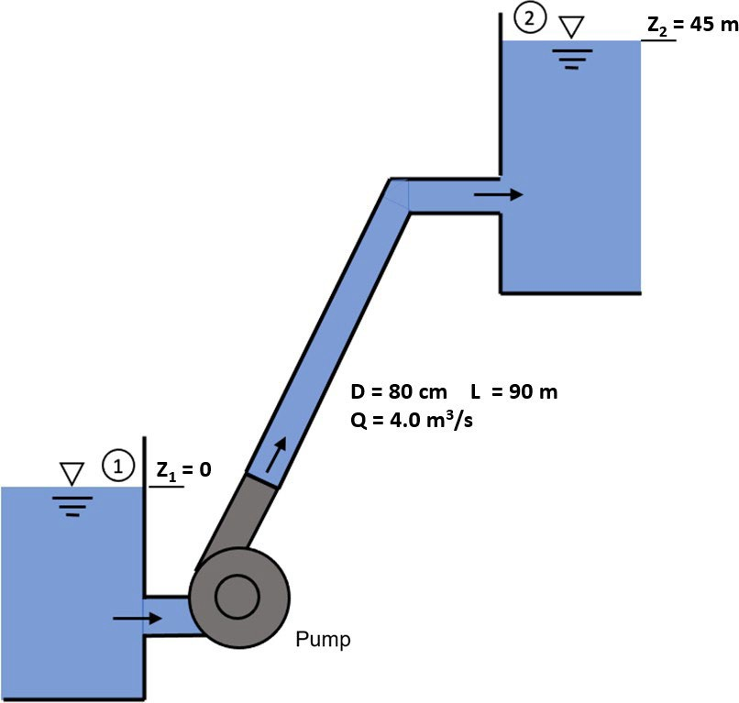

Figure 1: Reservoir and pump system sketch.

# Problem 1

The pump shown in Figure 1 is used to pump water from one open reservoir up to another open reservoir for storage. The top surface of the upper reservoir is located 45 m above the top surface of the bottom reservoir and is fed by a 90 m long, 80 cm diameter pipe. The flow rate throughthe pipe is held at a constant 4.0 m3/s. The frictional losses through the pipe can be computed

using the equation *h*

*friction*

*U*2 *L*

2*g d*

= *f*

where *f* is a dimensionless loss factor (obtain with Haaland

equation or Moody chart, using *ϵ/D* = 0*.*001). Assuming negligibly small minor losses (entry and exit and elbows) and the pump operates with an efficiency of 86 %, **what is the required input power to run the pump**?

Bernoulli's Principle



* Speed in the reservoir: V1 = V2 = 0

Therefore Z1 = 0

* Open to the atmosphere: P1 = P2 = 0

Assumptions:

α = 1 σ = p9

Water temp = 20°C

=>

V =

m/s

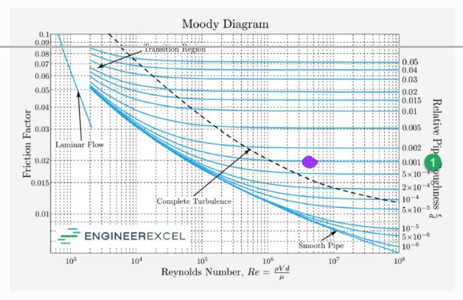

By nobody chart:

)

Power principle equation:

**Power required to run ump is ≈ 2401.158 Kilo Watt**

# Problem 2

Vapor in a multi-effect distillation plant such as the one shown in Figure 2 vapor can carry mist droplets with salt and other contaminants. To limit the amount of contaminants that reach the vapor exit (see arrow in the figure), we may want to control the speed of the vapor so that it can carry only the liquid droplets smaller than a certain size upwards.

Question: If we have a vertical flow of saturated water vapor at 0.15 bar absolute pressure and velocity of 1.0 m/s, what is the largest droplet size than can be carried up by this flow?

Assumptions and Hints:

* + Assume steam is saturated. Definition: Water heated to boiling point is vaporized and turns to *saturated steam*. If saturated steam is heated further (temperature above boiling point at given pressure), dry steam is generated and traces of moisture are gone (and in such case we have *superheated steam*).
  + Assume droplet is spherical and can be treated as a rigid sphere as first approximation
  + Use the density and viscosity of liquid and vapor water at the appropriate saturation tempera- ture. One reference for such properties can be found here: [NIST - Thermophysical Properties](https://webbook.nist.gov/chemistry/fluid/) [of Fluid Systems](https://webbook.nist.gov/chemistry/fluid/)
  + Hint: Work with a force balance. Assume that droplet would need to travel vertically upward (towards the screen above).

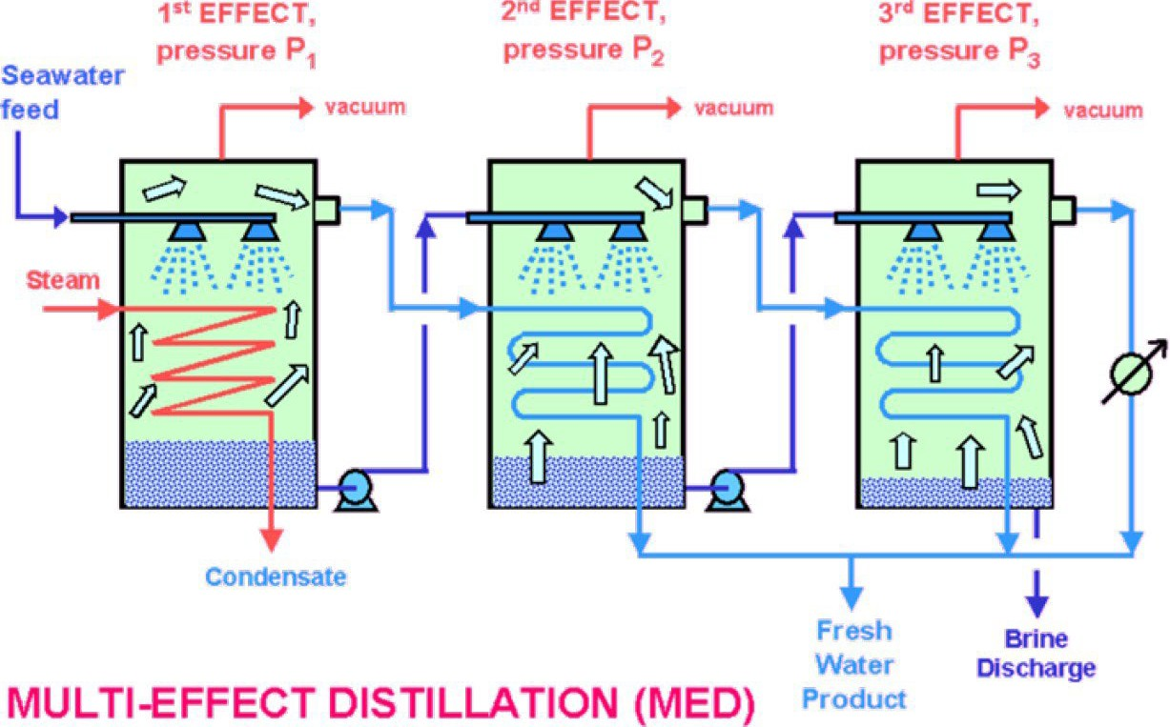

Figure 2: Figure from <http://www.separationprocesses.com/Distillation/Fig078b.html>.

Recall that for a rigid sphere, the coefficient of drag can be estimated as:



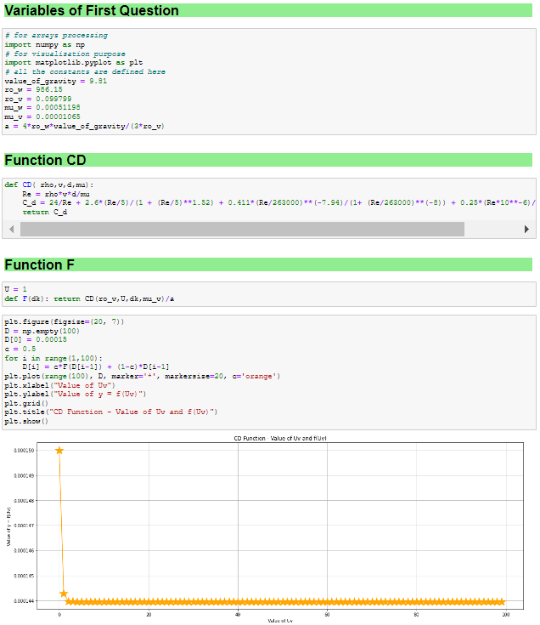

# the largest droplet size than can be carried up by this flow: 0.000143 m

**Problem 3**

To have a robust yet economical mass flow rate measurement with a relatively low pressure loss, a venturi flow meter may be utilized. Let us consider the performance and likelihood of cavitation in a horizontal venturi. We shall assume constant fluid properties, and denote the contraction ratio as *β*, defined as *β* = *dthroat/dpipe*. For a venturi, the mass flowrate can be determined as a functionof

fluid density, measured differential pressure ∆*p* = *ppipe* − *pthroat* and contraction ratio *β*.

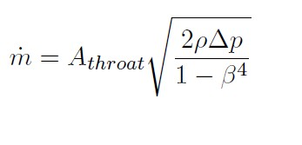

1. Sketch the venturi and label locations where you define pressures and velocities in the equations.

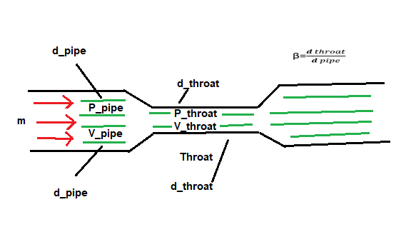

i.

•

•

•

velocities in the Equations:

𝑚𝑚̇ = 𝐴𝐴

𝑡𝑡ℎ𝑟𝑟𝑟𝑟𝑟𝑟𝑡𝑡

2𝜌𝜌∆𝜌𝜌

�

1−𝛽𝛽4

𝑑𝑑1

∆𝜌𝜌 = 𝜌𝜌𝑝𝑝𝑝𝑝𝑝𝑝𝑝𝑝 − 𝜌𝜌𝑡𝑡ℎ𝑟𝑟𝑟𝑟𝑟𝑟𝑡𝑡 > 0

𝛽𝛽 = 𝑑𝑑2 < 1

1. As no instrument is perfect, from the lectures we recall that above equation needs to be multiplied by a discharge coefficient. Assume it has a constant value of discharge coefficient *Cd*

= 0.965. Our venturi has *β* = 0*.*5 and *Athroat* = 0*.*004 m2. We shall assume that the uncertainty in density is 4 %, in area of throat 1 % and in *β* is 3 % for each, all with95 % confidence. If mass flow rate of 20 kg/s is to be determined within 5 % with 95 % confidence, **what is maximum uncertainty allowable for the differential pressure measurement**?

* 1. First, use the **Gauss method** to obtain the uncertainty for the pressure measurement.

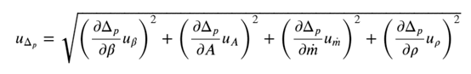

Gauss Method:

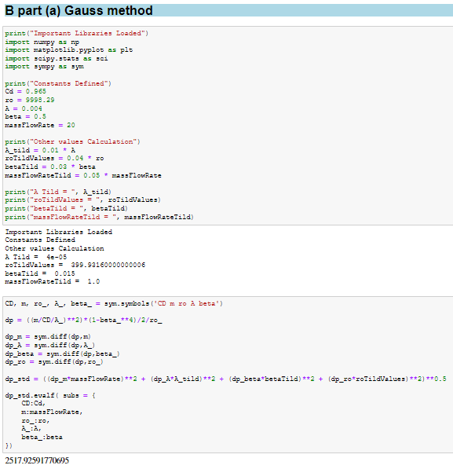

* 1. Then, implement the **Monte Carlo method** for the mass flow rate distribution, using the obtained pressure measurement uncertainty. Check whether the uncertainty for the mass flow rate matches the desired value.

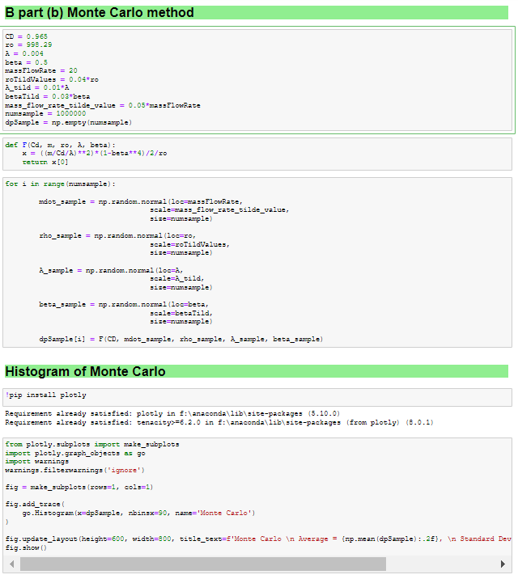

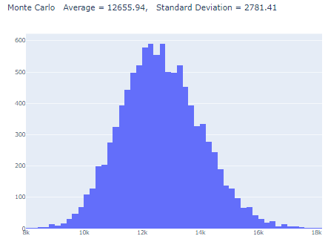

Maximum allowable uncertainty for differential pressure measurement is 10.98 %

1. Gaussian method: 1384.974 Pa
2. Monte Carlo method: 1390.344 Pa
3. If cavitation inception is expected at *σ* = *pref −pvapor*

1 *ρU*

≤ 1*.*8, with cavitation number defined

2 *ref*

based on ’reference’ pressure and velocity upstream of the throat. For the above flow rate, **what is minimum pressure allowed at the venturi inlet to likely avoid cavitation**? Assume water temperature is 20 *◦*C.

Hint: start by defining the cavitation number and be consistent with labeling from part A.

* 𝜎𝜎 = 𝑃𝑃−𝑃𝑃𝑣𝑣𝑣𝑣𝑣𝑣𝑣𝑣𝑣𝑣 ≤ 1.8

1𝜌𝜌𝑈𝑈2

2 𝑣𝑣𝑟𝑟𝑟𝑟

* 𝜎𝜎 𝑃𝑃𝑣𝑣𝑝𝑝𝑣𝑣𝑟𝑟−𝑃𝑃𝑣𝑣𝑣𝑣𝑣𝑣𝑣𝑣𝑣𝑣 = 1.8

1𝜌𝜌𝑣𝑣2

2 𝑣𝑣𝑝𝑝𝑣𝑣𝑟𝑟

**Solve for** 𝐯𝐯𝐭𝐭𝐭𝐭𝐭𝐭𝐭𝐭𝐭𝐭𝐭𝐭**:**

* 𝑣𝑣𝑡𝑡ℎ𝑟𝑟𝑟𝑟𝑟𝑟𝑡
* 𝑣𝑣𝑡𝑡ℎ𝑟𝑟𝑟𝑟𝑟𝑟𝑡

= 𝑚𝑚̇

𝜌𝜌𝐴𝐴𝑡𝑡ℎ𝑣𝑣𝑣𝑣𝑣𝑣𝑡𝑡

= 20

(998.2)(0.004)

* 𝑣𝑣𝑡𝑡ℎ𝑟𝑟𝑟𝑟𝑟𝑟𝑡𝑡 = 5.01 𝑚𝑚/𝑠𝑠

**Solve for** 𝒗𝒗𝒑𝒑𝒑𝒑𝒑𝒑𝒑𝒑**:**

* + 𝑣𝑣𝑝𝑝𝑝𝑝𝑝𝑝𝑝𝑝 = 𝑣𝑣𝑡𝑡ℎ𝑟𝑟𝑟𝑟𝑟𝑟𝑡𝑡 𝛽𝛽2
  + 𝑣𝑣𝑝𝑝𝑝𝑝𝑝𝑝𝑝𝑝 = (5.01)(0.5)2
  + 𝑣𝑣𝑝𝑝𝑝𝑝𝑝𝑝𝑝𝑝 = 1.25𝑚𝑚/𝑠𝑠

**Minimum Allowed Pressure at Venturi Inlet to avoid Cavitation will be:-**

∴ Pvapor = 2340 @ 20 C

∴ 𝜎𝜎=1.8 given from the question.

**Solve** 𝑷𝑷𝒑𝒑𝒑𝒑𝒑𝒑𝒑𝒑**:**

* 𝑃𝑃

1 2 + 𝑃𝑃

𝑝𝑝𝑝𝑝𝑝𝑝𝑝𝑝 = 𝜎𝜎 2 𝜌𝜌𝑣𝑣𝑝𝑝𝑝𝑝𝑝𝑝𝑝𝑝

𝑣𝑣𝑟𝑟𝑝𝑝𝑟𝑟𝑟𝑟

* 𝑃𝑃

( ) 1

2 + 𝑃𝑃

𝑝𝑝𝑝𝑝𝑝𝑝𝑝𝑝 =

* 𝑃𝑃𝑝𝑝𝑝𝑝𝑝𝑝𝑝𝑝 =

1.8 . 2 . 𝜌𝜌 . 𝑣𝑣𝑝𝑝𝑝𝑝𝑝𝑝𝑝𝑝

(1.8 . . (998.2) .

)

1

2

𝑣𝑣𝑟𝑟𝑝𝑝𝑟𝑟𝑟𝑟

(1.25)2 + 2340

* 𝑃𝑃𝑝𝑝𝑝𝑝𝑝𝑝𝑝𝑝 = 1403 + 2340
* 𝑃𝑃𝑝𝑝𝑝𝑝𝑝𝑝𝑝𝑝 = 3743.71𝑃𝑃𝑃𝑃 ≈ 3.74𝐾𝐾𝑃𝑃𝑃𝑃

# Problem 4

Assume we have a 600 mm ID pipeline that is 400 m long supplying water to an older desalination plant at a mass flow rate of 750 kg/s. Due to corrosion the average roughness of the pipe has increased to 4.5 mm, from the original 0.1 mm. Assume pumping efficiency of 82 %, electricity price of 0.15 USD/kWh. And, that you are pumping seawater at 20 *◦*C.

1. **What is the electricity cost per year** for this single pipeline?

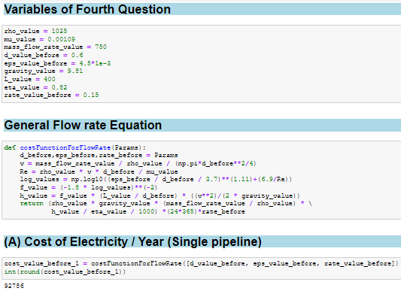

## The Electricity cost per year: 92,786.19 $

1. One option to reduce pressure drop and hence operating costs is to install a liner with a lower roughness. Assume a 5 mm thick liner with roughness of 0.2 mm can be installed with the cost of 300 USD per meter. Let’s say the current price of electricity is 0.10 USD/kWh, buta rise in the price is planned after 6 months without specific number.

Considering the higher the electric cost is, the sooner the liner installation cost will be recovered, **estimate how high the raised electricity price should be in order to recoverthe installation cost in 3 years**.

Also note: the liner could also block leaks the pipeline may have had.

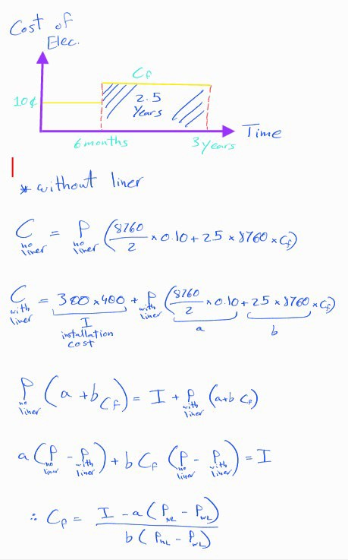

* *Without linear*

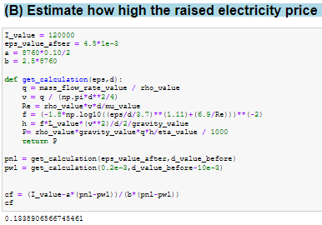

**Electricity price needed to cover the remaining installation cost: 0.13389 $/hr**

# Problem 5

All other things being equal, smoother pipe, larger diameter, more gradual pipe transitions etc. will lead to a reduced pressure drop in pipe network. And, ideally none of the components should be inflicted by cavitation. During the course we discussed pressure loss estimation based of textbook approaches, and calculations nowadays typically handled by commercial codes. For this assignment, you will examine a simple pipe network and study effect of uncertainty to network performance using the Monte-Carlo method for uncertainty propagation.

Use a textbook approach (with friction factors e.g. from Moody diagram (Figure 6.13 in White) based on given roughness White (1998)) to simulate the performance the network should have. *Note that simulated performance may deviate from measured performance not only due to uncertainty about initial dimensions of components, but also due to installation deviating from design (e.g. extra bends and rough welds), effects of corrosion and fouling on roughness given age of pipeline, etc.*

For a complex pipe network, commercial or freeware codes would typically be used to evaluate performance of the network. While the solution methodologies vary, the basic conservation lawsremain unchanged. Hence, let us consider a simple example pipe network and a) write our own code to solve for the flow rates, b) use WNTR simulation library in python to resolve the same network and ensure your answers match, and c) implement a Monte-Carlo solution.

Assume pipes’ dimensions have uniform distribution between 98% and 102% of nominal diameters and between 99% and 101% of nominal lengths. The roughness has normal distribution with standard deviation 1/5 of its nominal value. Rerun the Monte Carlo simulation with water properties at 10*◦*C and 30*◦*C (in addition to the original design point of 20*◦*C) in order to evaluate the influence of temperature on system performance.

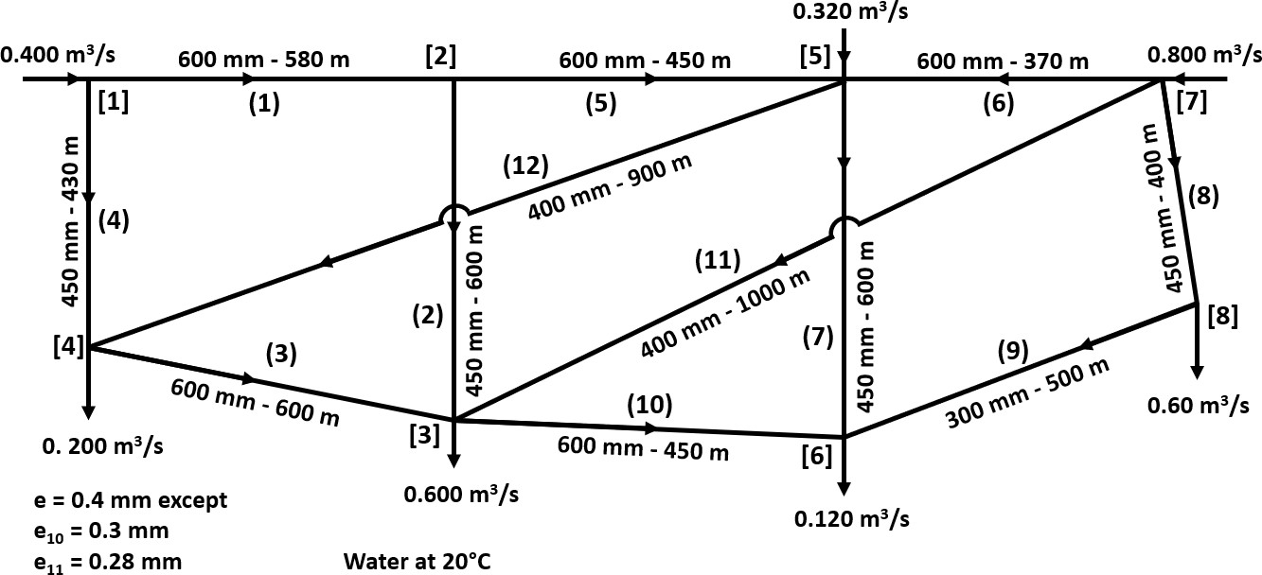

Figure 3: Pipe network to analyze. Figure adapted and modified from Jeppson (1974), and the values have been changed.

**NOTE: The WNTR simulation library in python will be used for comparison in this problem and can be installed in your python distribution. WNTR is an open source library based on EPANET. Please see the Appendix in the main notes docu- ment or** <https://wntr.readthedocs.io/en/latest/installation.html> **for instructions on installing and implementing WNTR.**

1. Use whichever method you are most comfortable with (Linearized approach from lectures, Hardy- Cross, Newton-Rhapson, or other) to setup equations and then **solve the flow rates and pressures throughout the network**. Start from conservation of mass and consider only the major losses for

∆*p* calculations (i.e. neglect minor losses due to fittings and instruments).

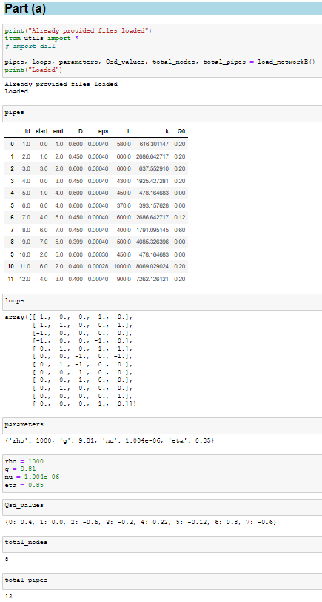

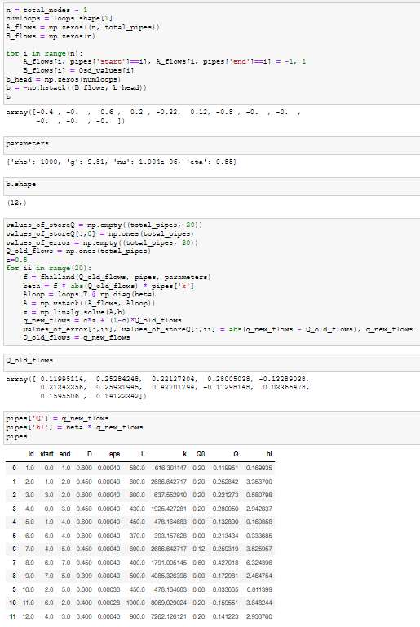

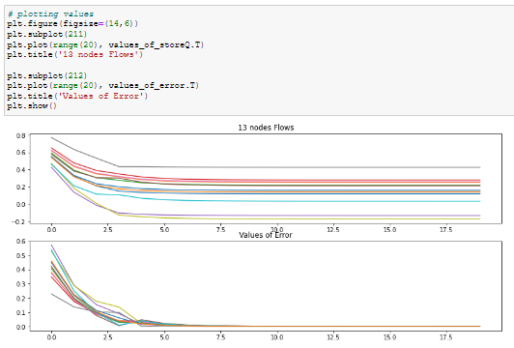

1. Assuming node [1] is at 100 kPa (gauge) and that water to supply nodes ([1], [5] and [7]) was delivered from open reservoirs at 0 kPa (gauge) by pumps that are 85% efficient, **how much en- ergy (in kWh) per day is required to deliver the water (report for each pump)**?

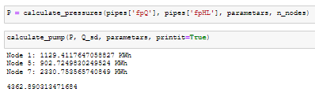

## Maximum Power Per day required to deliver the water: 4,362.89 kWh

1. Use WNTR to check solution of part a. **Report your results for flow rates and pressures throughout the network.**

*Hint: WNTR requires at least one reservoir, so even though we know all of the flowrates into the network, you will need to set one as a reservoir. WNTR will solve for the flow from the reservoirinto the network and you can check to confirm that it matches the given value and mass is con-served. Also, make sure that all of your junctions and pipes have unique names.*

*Check point: To check your result, the flowrate in pipe 2 should be approximately* 0*.*24 *m*3*/s and the head at node 3 should be approximately* 7 *m.*

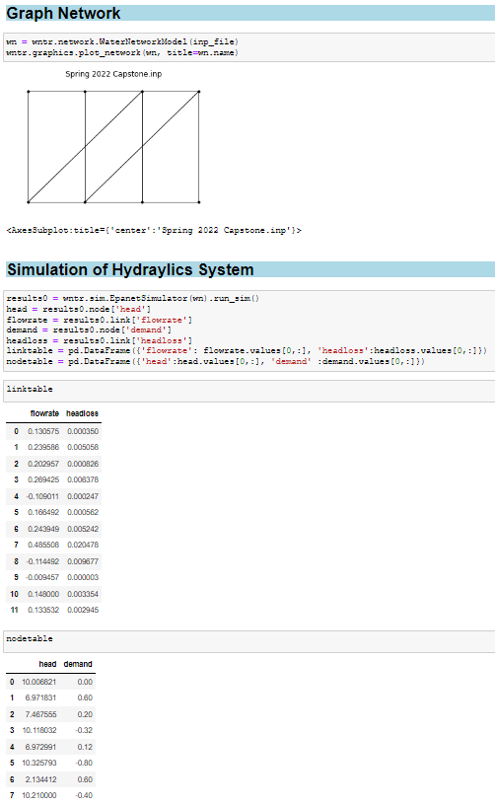

1. Use WNTR and estimate the effect of uncertainty in pipe conditions of pumping power needed to supply network shown in figure 3. Use your code and Monte-Carlo method for propagating uncertainty and consider i) uncertainty in pipe roughness, ii) uncertainty in pipe length, and iii) uncertainty in pipe diameter (see table 1). Perform a convergence study to show that you have run enough iterations for your results to have converged. To estimate uncertainty in roughness, use a normal distribution with the mean matching the nominal roughness and the standard deviation of 1/5 the mean. **Report the uncertainties in pressure throughout the system based on your MC simulation as well as the uncertainty in required pumping power at the supply node 5.**

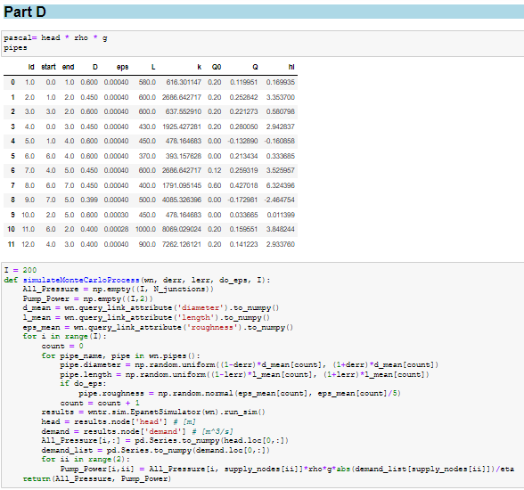

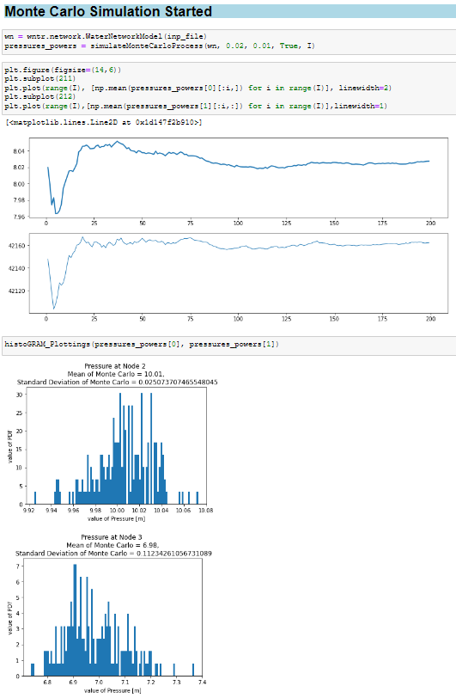

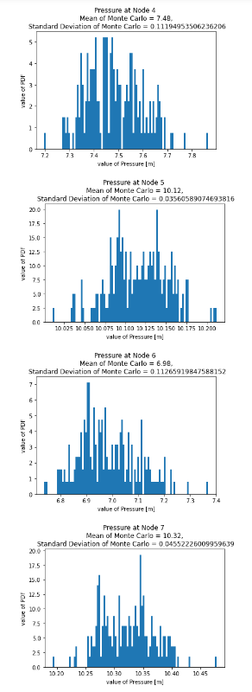

1. erties in the input file for each of these two limiting cases, then rerun your MC simulation. **Report the uncertainties in pressure throughout the system based on your MC simulationas well as the uncertainty in required pumping power at the supply node 5 at the different temperatures. Compare these to your results from part d) and discuss what effect does**
2. 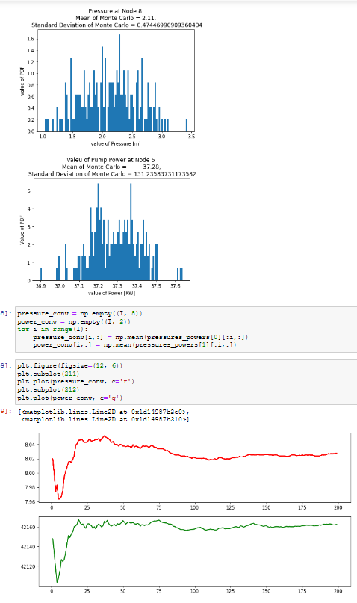**temperature have on your results?**
3. Consider what happens if water temperature ranges from 5*◦*C to 30*◦*C. Modify your fluid prop-

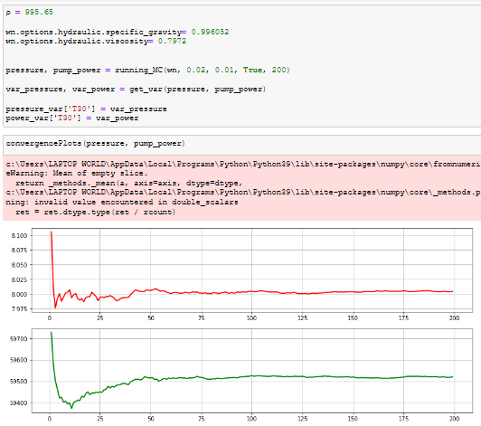

As observed, while the water temperature increases the readings of the power and pressure increases with the uncertainties.

1. Investigate the importance of considering each of the three sources of uncertainty. To check this, re-run simulation while setting one uncertainty at a time to be zero and see what effect that has. **Report results from each case and briefly discuss your observations on how they change from your results in part d) and from case to case (i.e. which uncertainty has the most significant effect?).**

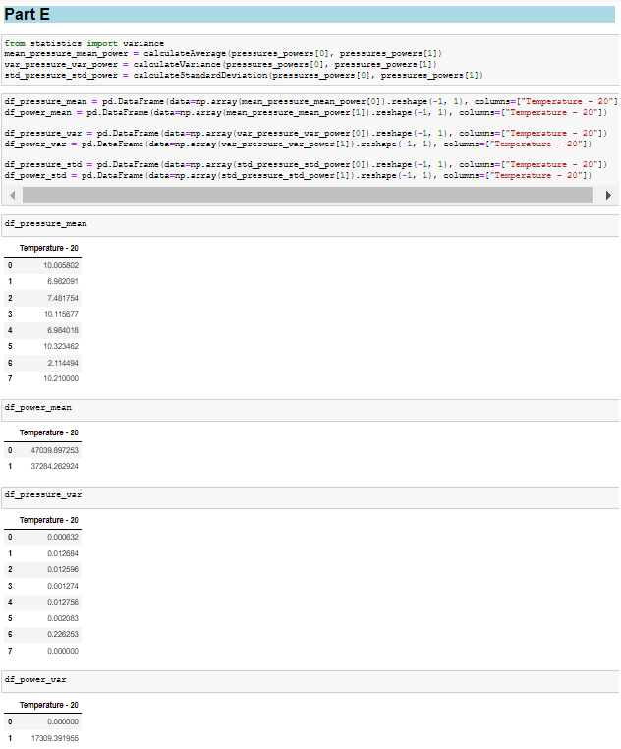

## 

## The implemented sources caused the Power & Pressure to reduce in all cases.

**The lowest effect happens when removing the length. The Highest effect happens when removing the diameter.**

1. Within each pipe, **calculate wall shear stress and viscous length scale** (SSA will provide example upon request), and **estimate if a superhydrophobic coating with damage thresh- old of 10 Pa of shear and and manufacturable with rms roughness of 100** *µ***m might result in drag reduction in each pipe segment** (Requires having roughness below ∼ 5 viscous length

scales. For simplicity: assume that there would be a way to avoid entrainment of gas from the surface

into the flow and a way to supply gas to the surface at pipeline pressure – not necessarilyachievable presently).

|  |  |  |  |
| --- | --- | --- | --- |
| Pipe Index Uncertainty: | Diameter [mm]  ±2% Uniform | Length [m]  ±1% Uniform | Roughness [mm] Normal (*σ* = 0*.*2*µ*) |
| (1) | 600 | 580 | 0.400 |
| (2) | 450 | 600 | 0.400 |
| (3) | 600 | 600 | 0.400 |
| (4) | 450 | 430 | 0.400 |
| (5) | 600 | 450 | 0.400 |
| (6) | 600 | 370 | 0.400 |
| (7) | 450 | 600 | 0.400 |
| (8) | 450 | 400 | 0.400 |
| (9) | 300 | 500 | 0.400 |
| (10) | 600 | 450 | 0.300 |
| (11) | 400 | 1000 | 0.280 |
| (12) | 400 | 900 | 0.400 |

Table 1: Pipe properties in the network being analyzed.

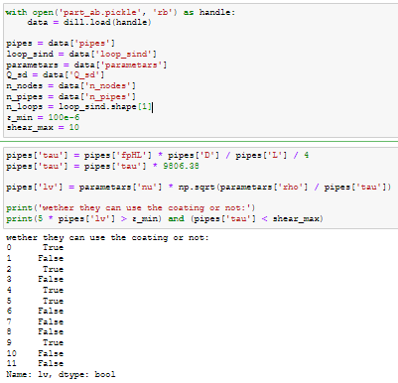

## Pick ONE bonus task if you wish to get extra points that can offset points missed from previous questions:

* + **Bonus task h)** What would be the achievable reduction in pumping power requirements if the pipeline were to be one standard size larger or have smoother surfaces owing to initial material selection or maintenance?
  + **Bonus task i)** Name three methods you could use in this water pipe network to measure the flow rate, and name the underlying physical operating principle used by each instrument. *Hint: See day 10 lecture notes.*
  + **Bonus task j)** If you observe in your pipe network unusual dynamics and suspect gas may be present, you might benefit from phase fraction measurements. Name two ways to measure phase fractions (i.e. volume or mass fraction of gas and water) in a pipeline and briefly explain their operating principle. *Hint: See day 10 lecture notes.*

# References

Roland W Jeppson. Steady flow analysis of pipe networks: an instructional manual. 1974. Frank M White. *Fluid Mechanics, fourth edition*. McGraw-Hill Higher Education, 1998.